**App Proxy Registration**

Azure Active Directory (AD) Application Proxy helps you support remote workers by publishing on-premises applications to be accessed over the internet.

You can publish applications through the Azure portal to provide secure remote access from outside your network

**Steps to Create App Proxy Registration**

1. Enable Application Proxy, need

* A [Microsoft Azure AD basic or premium subscription](https://azure.microsoft.com/pricing/details/active-directory).
* An application administrator account.

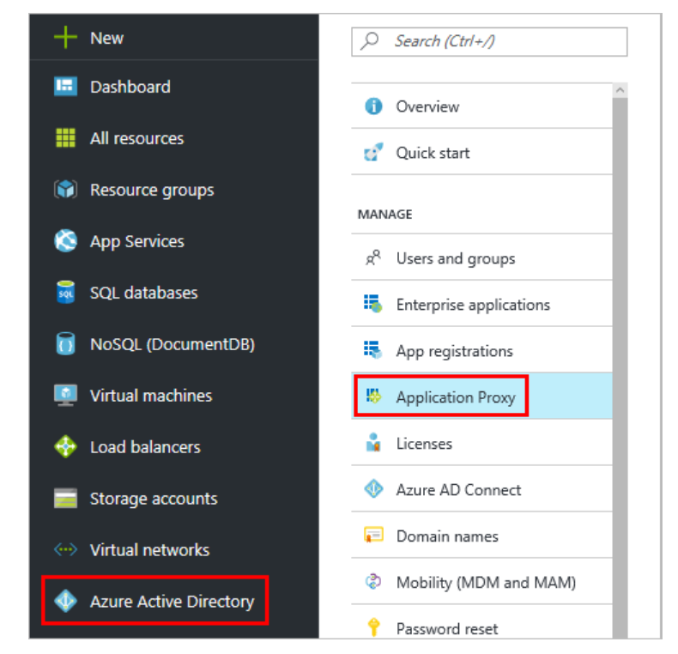

1. We need to download connector to enable application proxy

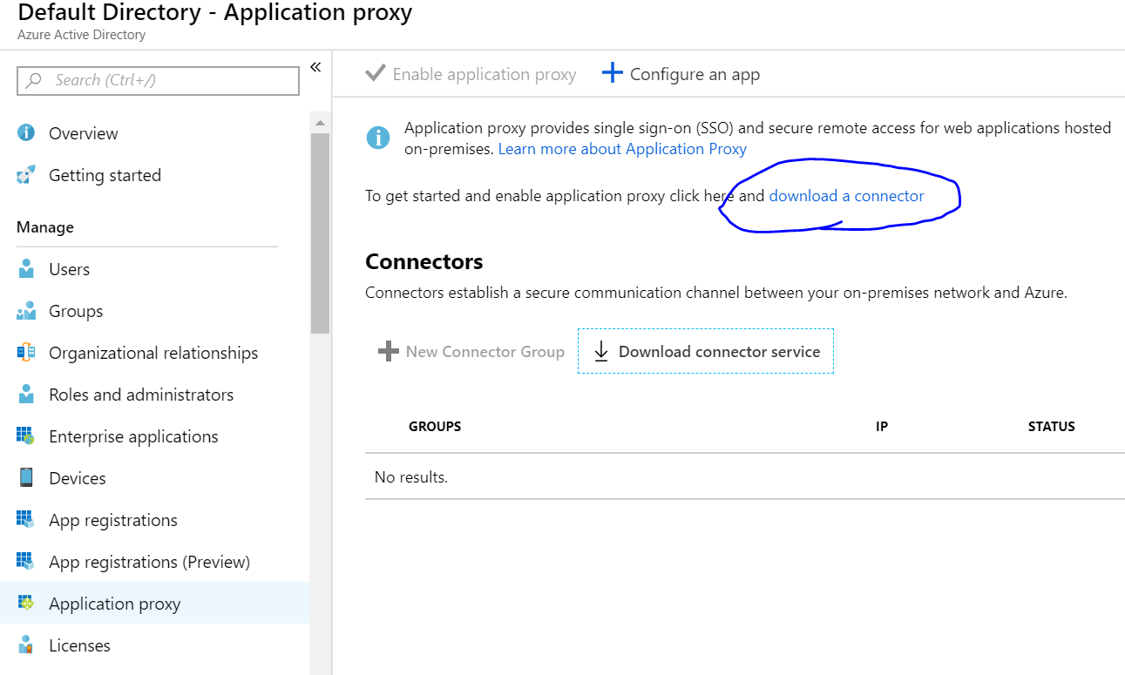

1. Install downloaded connector

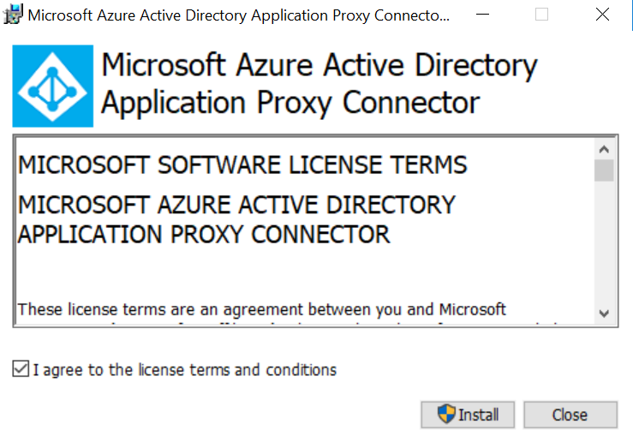

We need to login as Global admin, else we will get below error.Your global administrator tenant may be different from your Microsoft Azure credentials

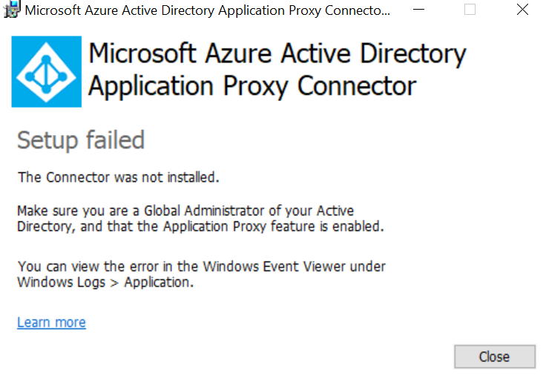

1. **IE Enhanced Security Configuration** is set to **On** the server where you are installing the connector, you may not see the registration screen. To get access, follow the instructions in the error message. Make sure that Internet Explorer Enhanced Security is off.
2. Test that the connector installed correctly

* You can confirm that a new connector installed correctly by checking for it in either the Azure portal or on your server
* Azure portal, sign in to your tenant and navigate to **Azure Active Directory** > **Application Proxy**. All of your connectors and connector groups appear on this page.
* In server list of active services for the connector and the connector updater

Below screenshot attached for reference

